HOW to use the code:   
  
a) run: run_filtering_and_features_extraction.m:   
signal filtering and feature extraction   
  
b) open a terminal and write :   
 python Ultimate_code.py

OR

Open a jupyter notebook :

scaled_anova_linear_svm.ipynb

EXPLANATION:  
1) Matlab signal processing and feature extraction   
Step 1:

Data cleaning: bandpass filtering (0.1-30 Hz) of EEG channels

Data selection: using the trigger signal

MATLAB file: filtroEEG.m

Step 2:

Feature extraction: various statistical measures in different band frequencies:

MATLAB file: EEGyesAllFeatures.m

EEGnoAllFeatures.m

Figure 1: features extracted
  
2) Feature Selection and Classifier (python)

Step 3:

Feature Selection:

top k-best score with ANOVA analysis and F-test

Step 4:

Model:

Hard margin SVM with linear kernel, C=1. (Note: since the smallness of the dataset, the performances of the model were assessed with a full search using leave-p-out method with p = 1,2,3)

Function:

performance_assesment_fraction_std

Step 5:

Results: k = 61, accuracy=

accuracy varying train/test dimensions (figure) (note: error bars are standard deviation of the results of 10000 experiments with different sampled instances given the train/test fraction)

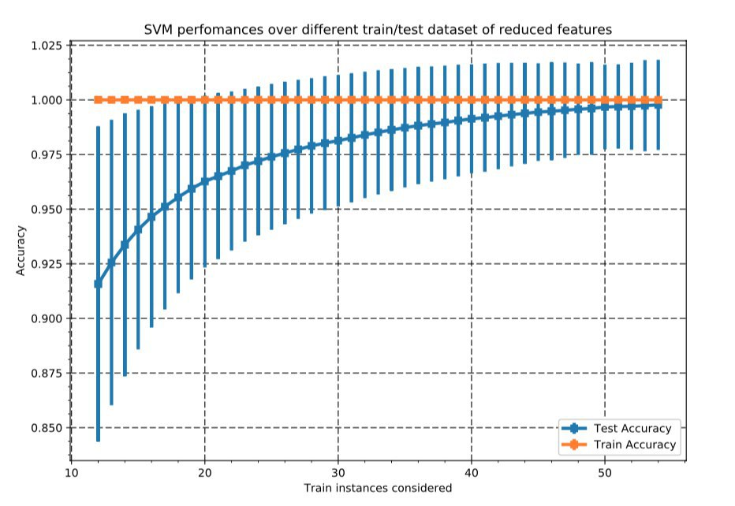

The 61 features selected are: